**WEEK-6**

**REACT**

**5.ReactJS-HOL**

**Q. My Academy team at Cognizant want to create a dashboard containing the details of ongoing and completed cohorts. A react application is created which displays the detail of the cohorts using react component. You are assigned the task of styling these react components.**

**CODE:**

**Step 1: Unzip the React application and extracted to**

C:\Users\hp\Documents\cohorttracker

**Step 2: Open Command Prompt and go to the project directory and Restore Node Packages using: npm install**

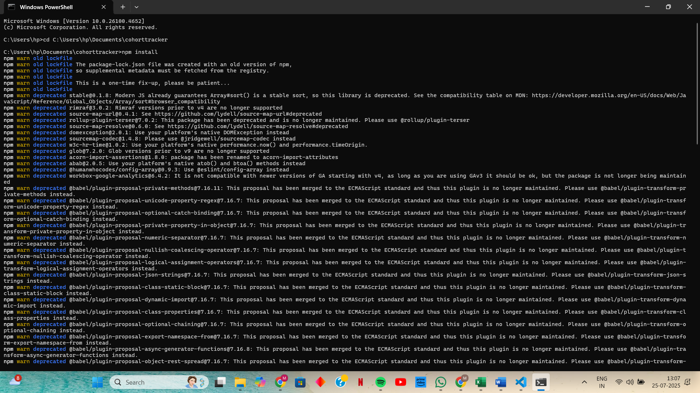

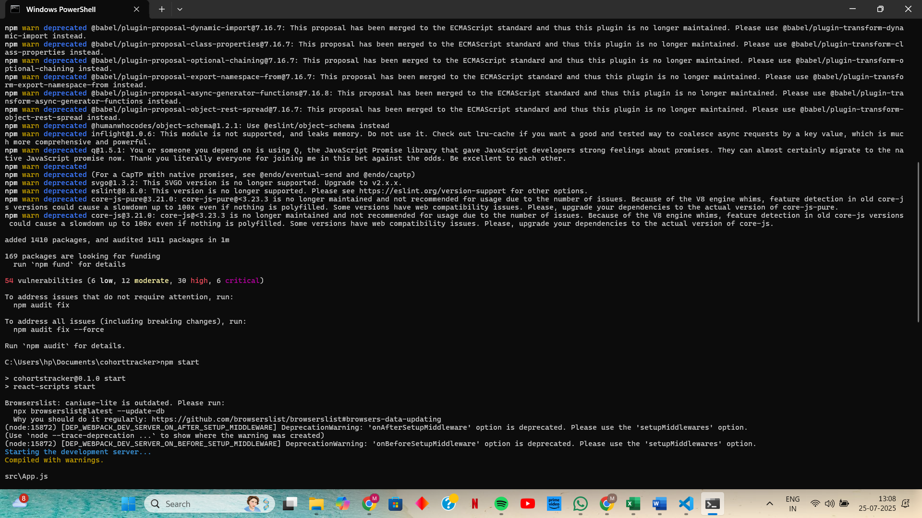

**Step 3: Create a CSS Module in vs code inside src folder named as CohortDetails.module.css**

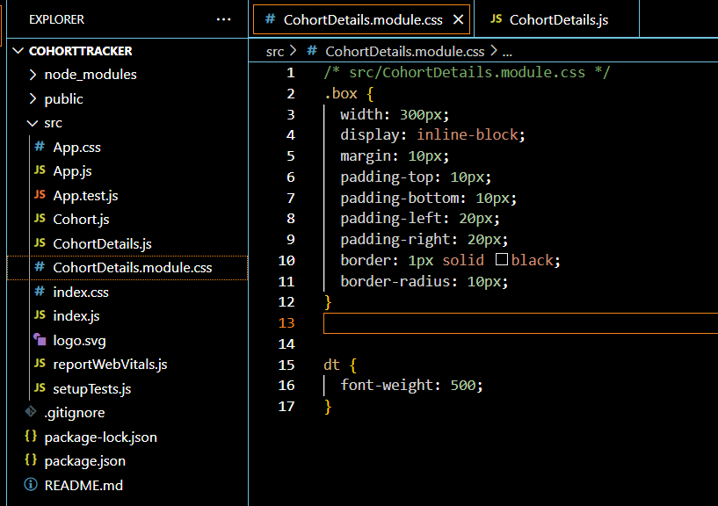

**Step 4: Open and Modify the CohortDetails Component**

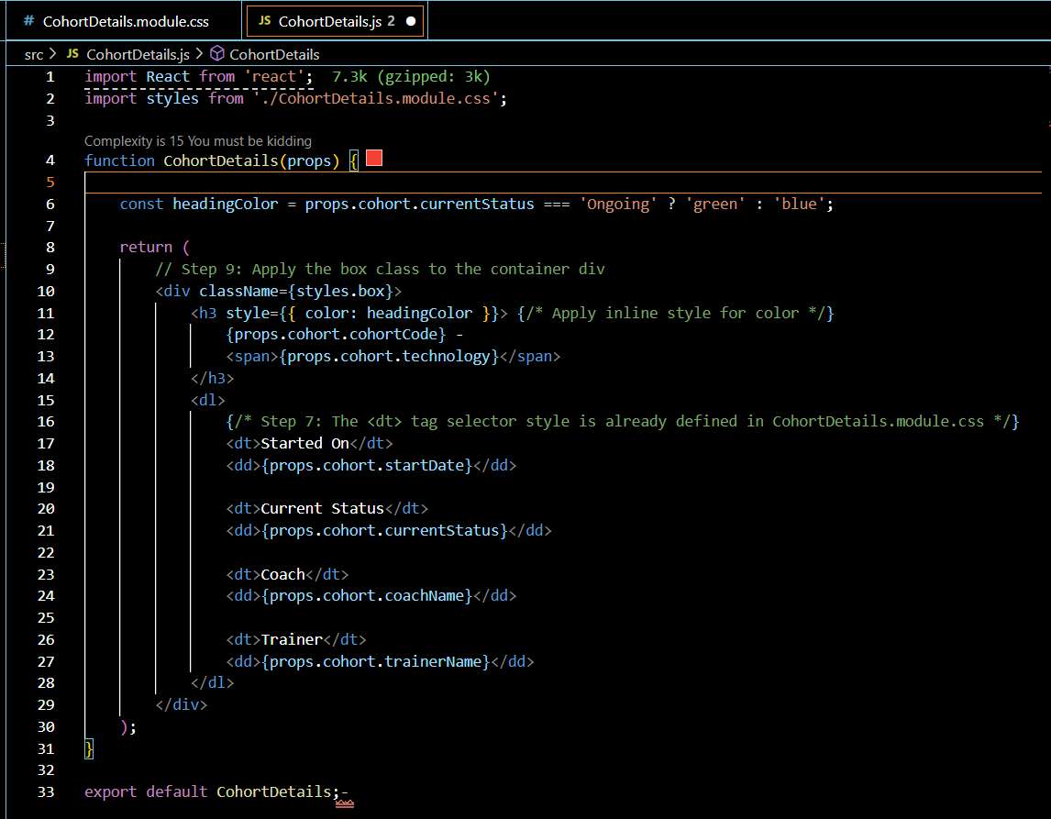

**Step 5: run the application using command in cmd: npm start**

**OUTPUT:**

